12-2: Updating Column Values and Deleting Rows

**Vocabulary**

Modifies existing rows in a table **UPDATE**

Retrieves information from one table & uses the information to update another table COPY **correlated subquery update**

Ensures that the data adheres to a predefined set of rules **Integrity Constraints**

Deletes information on a linked table based on what was deleted on the other table **correlated subquery delete**

Removes existing rows from a table **DELETE**

Try it / Solve it

1. Monique Tuttle, the manager of Global Fast Foods, sent a memo requesting an immediate change in prices. The price for a strawberry shake will be raised from $3.59 to $3.75, and the price for fries will increase to $1.20. Make these changes to the copy_f_food_items table.

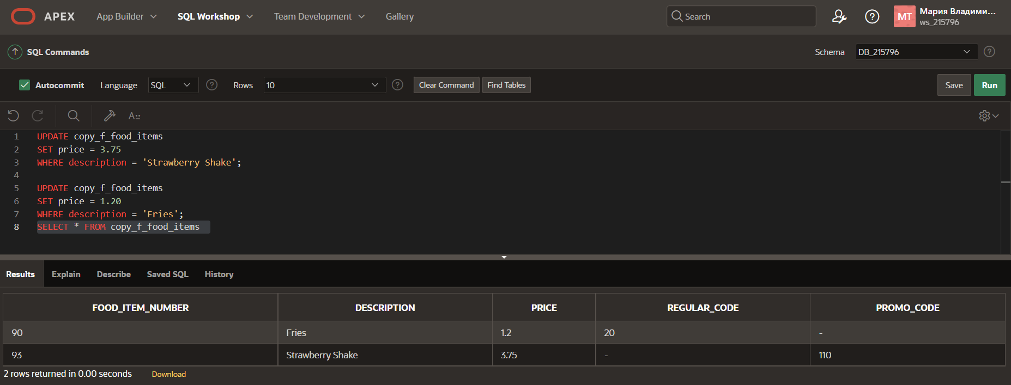

1. Bob Miller and Sue Doe have been outstanding employees at Global Fast Foods. Management has decided to reward them by increasing their overtime pay. Bob Miller will receive an additional $0.75 per hour and Sue Doe will receive an additional $0.85 per hour. Update the copy_f_staffs table to show these new values. (Note: Bob Miller currently doesn’t get overtime pay. What function do you need to use to convert a null value to 0?)

1. Add the orders shown to the Global Fast Foods copy_f_orders table:

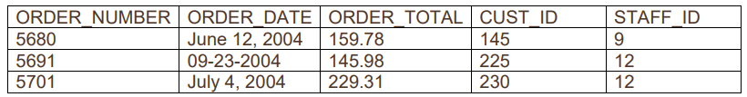

1. Add the new customers shown below to the copy_f_customers table. You may already have added Katie Hernandez. Will you be able to add all these records successfully?

1. Sue Doe has been an outstanding Global Foods staff member and has been given a salary raise. She will now be paid the same as Bob Miller. Update her record in copy_f_staffs.

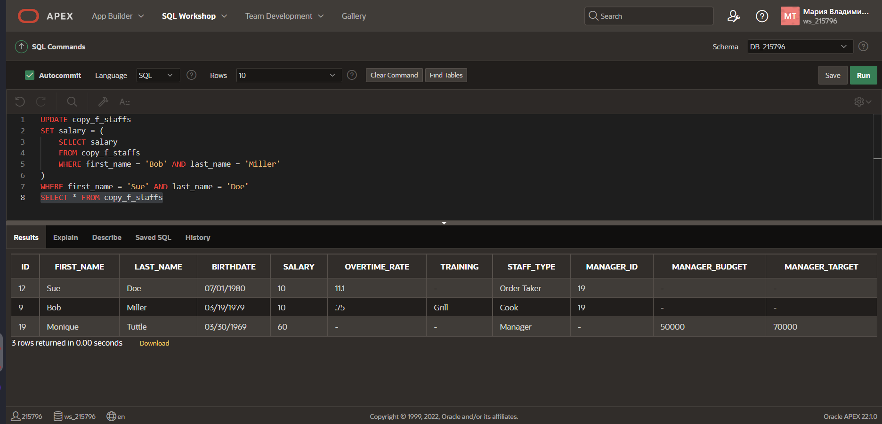

1. Global Fast Foods is expanding their staff. The manager, Monique Tuttle, has hired Kai Kim. Not all information is available at this time, but add the information shown here.



1. Now that all the information is available for Kai Kim, update his Global Fast Foods record to include the following: Kai will have the same manager as Sue Doe. He does not qualify for overtime. Leave the values for training, manager budget, and manager target as null.

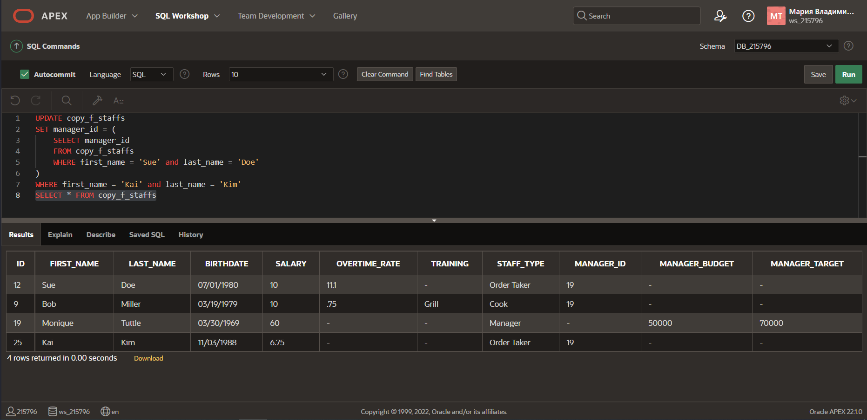

8. Execute the following SQL statement. Record your results.

DELETE from departments

WHERE department_id = 60;

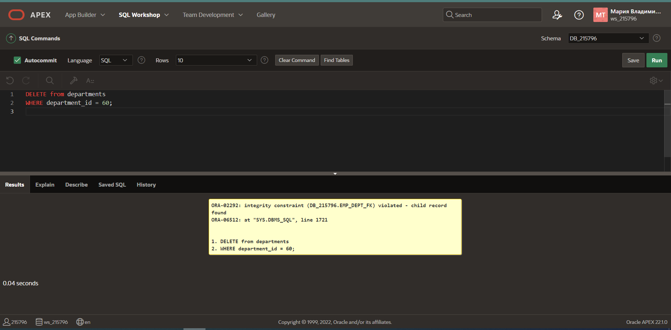

9. Kim Kai has decided to go back to college and does not have the time to work and go to school.

Delete him from the Global Fast Foods staff. Verify that the change was made.

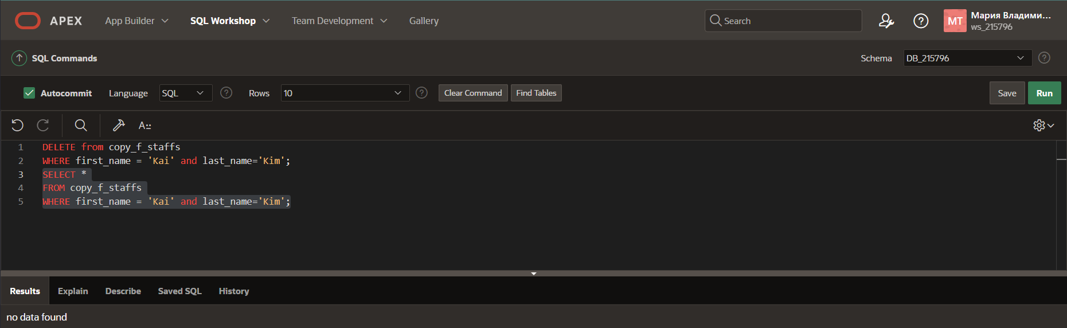

10.Create a copy of the employees table and call it lesson7_emp;

Once this table exists, write a correlated delete statement that will delete any employees from the

lesson7_employees table that also exist in the job_history table.

